**Learning about urban mitigation solutions**

William F. Lamb, Felix Creutzig, Max C. Callaghan, Jan C. Minx

**Climate change assessments by the IPCC and others put increasing emphasis on cities. Cities are key actors in climate change mitigation and provide a test-bed for policy experiments and social change. While a coherent understanding of barriers and opportunities for climate solutions remains fragmented, there is already a large body of case studies literature to learn from and translate into different urban contexts** 1**. A number of practical and conceptual challenges hinder systematic analysis. First, the literature tends to focus on cases in large, wealthy cities in the global North. Yet, the majority of the global population is residing in much smaller agglomerations in the Global South with only partially developed urban infrastructures. Second, a comprehensive overview of which mitigation topics have been researched for what cities is currently lacking. Third, secondary analysis of the case study literature is extremely sparse and does not employ structured methods. Here we perform a systematic review of the literature landscape of case studies on climate mitigation solutions in cities. We find that learning about urban mitigation solutions requires concerted efforts to systematically aggregate the dispersed knowledge on generalizable topics, such as spatial scalability, from individual cities and issues to comparative reviews on large set of cities with multiple entangled climate mitigation strategies.**

Cities experience similar dynamics of agglomeration 2, are faced with structurally comparable decarbonisation challenges 3,4 and are increasingly interconnected through trade, globalisation and coordinated social or political movements 5–8. The opportunities for comparative research across cities are therefore widely discussed 9,10, underlining an important role for case studies of local mitigation actions and horizontal comparisons of actions between different types of cities. Learning from these studies is important to satisfy increasing demands for a solutions orientation in the field 11 and to support the urgent upscaling of efforts required to keep global warming below 1.5°C or 2°C 12.

The IPCC’s 6th Assessment Cycle will again include dedicated chapters on urban systems, in both Working Groups II and III. Urban assessments and research networks are in their infancy, but gaining momentum, as exemplified by the Urban Climate Change Research Network (UCCRN), and in renewed efforts to foster a global urban science 13,14. Case studies are prominent in these assessments: often they are presented in dedicated boxed sections (IPCC, ARC3.2), are curated in libraries of urban initiatives (ICLEI), or are simply placed in the text as examples of policies and actions. But despite their importance to narrative flow and showcasing best practices, individual cases can have an ambiguous scientific role – often they tend towards ‘success stories’ rather than failures, favour description over analysis, and lack claims of generalisability. We have yet to understand how well different climate policies work, for which types of cities, under what circumstances. This is a precondition for applying scientifically robust lessons from case study evidence to other contexts.

Multiple issues in the underlying literature confound learning about urban mitigation solutions. First, cities are known for their conceptual challenges, including how to systematise urban physical boundaries for comparison 14,15, or select topics that are ‘urban’ and not simply general social or global processes 2. Second, there is a supposed bias towards conducting cases in the global North and excluding the urban experiences of the global South 2. Third, the published literature on climate change is following an exponential growth trend 11 and the urban mitigation field is no exception 1. Scientists are no longer capable of tracking developments in their field. This raises the risk that attention will only be paid to highly visible, contentious, or successful examples of urban climate change mitigation – overlooking failures and their opportunities for learning, and insights from less well known locations and contexts. Finally, the case study format itself is open to questions of academic rigour and a perceived lack of generalisability, despite its potential for explanatory power and empirical richness 16.

Here we take stock of the case study research on urban mitigation so far, assessing the extent to which these issues remain unresolved and suggest ways forward. Our analysis focuses on three questions: (1) which types of cities do we know about, in terms of population size and global region? (2) What mitigation topics do we know about, for which cities? And (3), what secondary analysis is there of the urban case study research? We identify a rich and varied literature of urban case studies, albeit one with regional and topic biases, and a distinct lack of secondary analysis and learning on these studies.

We obtain a sample of urban mitigation articles using a search query that combines synonyms for “urban” and “mitigation” in the Web of Science and Scopus literature databases (Table 1). Our interpretation of case study research is straightforward: if an article mentions a city name in the abstract or title, we assume it is a case study located in the city (or cities) mentioned. We use the Geonames database of geographic locations to identify city names. Of the approximately 12,918 articles identified in WOS and Scopus using our query, 3,440 directly refer to a city in the abstract or title. Double counting where an article mentions multiple cities, we obtain 4,730 case studies. We extract citation information from these databases, in order to observe which types of cities are well referenced in the literature. We divide citations equally among cities in double-counted articles.

|  |  |
| --- | --- |
| Urban synonyms | Mitigation synonyms |
| ("urban*" OR "municipal" OR "city" OR "cities" OR "metropolitan") | (“Paris Agreement” OR “low carbon” OR "decarboni*ation" OR (“energy” OR “carbon” OR “CO2” OR “GHG” OR “greenhouse gas” OR “climat*”) NEAR/3 ("mitigation" OR "reduc*" OR "polic*" OR "governance")) |

Table : Search query for urban climate mitigation literature. The two strings are combined with an ‘AND’ operator and entered as a topic search in the Web of Science, and a title-abstract-keyword search in Scopus.

**Urban case studies are biased towards large cities and the global North**

Urban form and infrastructures persist on the order of decades to centuries, shaping energy use and emissions in the process. With the window on 1.5°C rapidly closing it is essential to immediately initiate transformations in well-developed cities – and to guide emerging cities towards compact, low-carbon urban forms prepared for deep decarbonisation 17,18. Global urban population data suggests priorities: the majority of the world’s urban population currently resides in medium to large cities in Asia, and projected urban growth in the 21st century will take place mainly in small and medium-sized cities in Asia and Africa 17,19. Yet these are precisely the cities on which we lack case study research.

Figure 1 shows the spread of case study research across different city sizes, from a small number of familiar ‘mega-cities’ (over 10m inhabitants), to dozens of smaller national and regional capital cities (1-10m), and hundreds of yet smaller regional metropoles. The majority of research focuses on larger cities, with a small number of mega-cities receiving particular attention: Beijing (284 articles), New York (146), Shanghai (140) and London (117). Other cities are mentioned in fewer than 100 articles each.

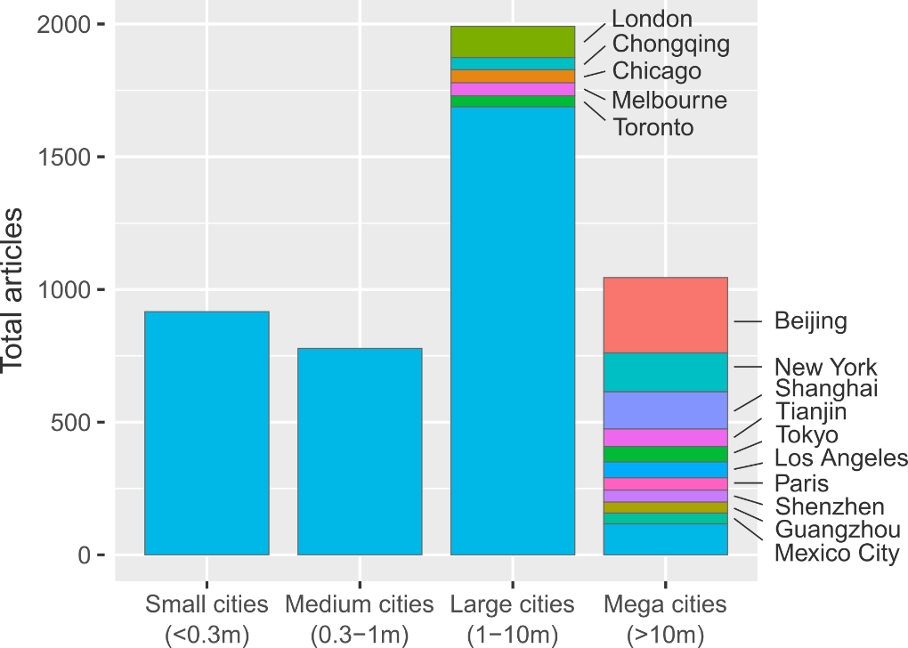

Figure : Summed urban climate mitigation articles, grouped according to city size. Where available, urban agglomeration data is used. The 15 most frequently studied cities are labelled.

The current focus on larger cities does not seem to be justified in multiple dimensions. Just 10% of the world’s urban population lives in mega-cities, compared to 40% in small cities – yet both groups are treated equally, each receiving approximately 20% of the case studies we find (Figure 2). A particularly stark divide can be seen in Asia, where the low proportion of mega-city inhabitants (10%) is served by over 40% of the urban case study literature in this region. In all regions, the smallest urban centres are consistently under-represented. This pattern is repeated for literature citations, with progressively larger cities receiving, on average, more citations (SI Text Fig 1).

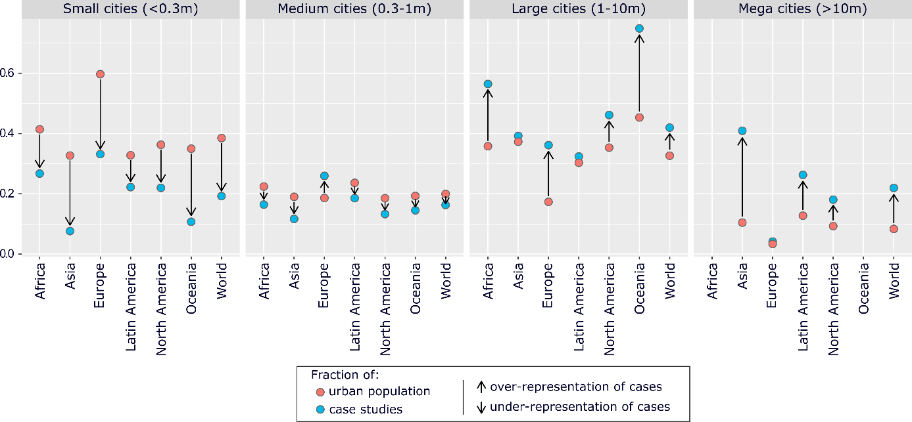

Figure : Size bias in urban mitigation case study research. Fractions of population and case studies are relative to regions.

Regionally, we observe a clear bias towards Europe and North America, which receive an outsized share of articles relative to their small proportion of the global urban population (SI Text Fig 1). The opposite trends prevail in Asia, Latin America and Africa, which are systematically under-studied in the literature. For instance, approximately 16% of the global urban population currently lives in African cities, yet only 4% of all case studies are dedicated to this region (SI Text Fig 2). In light of projected urban growth in the 21st century, which will take place primarily in X (SI Text Fig 3), further research on these areas emerges as a clear priority.

**Demand-side topics dominate urban case studies**

Energy demand reduction is increasingly seen as a crucial component of ambitious climate mitigation 20,21. Cities, as the site of everyday behaviours and practices, offer significant scope for shaping energy demand through infrastructures, land-use planning and localised social change 22. We therefore see an important role for urban research in uncovering the contexts and constraints surrounding such demand-side measures, not least the manifold trade-offs and synergies they have with broader sustainability issues and human well-being 23,24. Case studies may be well suited for this task, due to their rich contextual analysis and ability to integrate diverse quantitative and qualitative lines of evidence.

As it is increasingly difficult to track the development of rapidly growing scientific fields, we turn to natural language processing methods to outline the scope of mitigation research being carried out on cities. Using the identified corpus of 3,440 case studies we construct a matrix of documents and the words they contain (abstracts only), factorising to obtain the ‘topics’ that describe commonly co-occurring words across the document set (we subsequently refer to this as “topic modelling”; see methods). In essence, machine reading software discovers the latent topics that permeate the document set and categorises each document accordingly, substituting for the laborious task of reading and tagging each article by hand. The unsupervised ‘learning’ in this method also reduces subjectivity in one’s overall assessment of a body of literature.

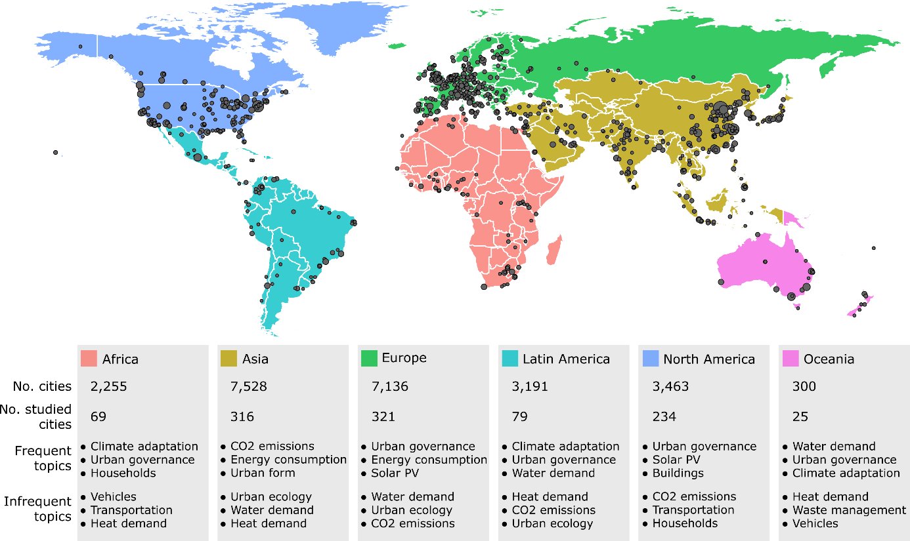

Figure : Urban case study cities and topics by region

We isolate 17 topics areas in the set of case studies (SI Text Table 1). Demand-side issues are indeed prevalent, for instance through topics such as transportation, waste management, and energy and heat demand in buildings – alongside issues of urban governance, urban form and CO2 emissions accounting. A single supply-side topic emerges on solar PV. Wider sustainability issues such as air pollution, water demand, urban ecology and climate adaptation are also integrated in the case studies we identify.

As each case study document is marked up by a combination of topics, we can scale-up the topic analysis to groups of documents, for instance on individual cities, or to global regions. At the regional level, we observe that emissions accounting and urban form are frequent subjects of case study research situated in Asia (Figure 3). This contrasts with the prevalence of urban governance (which captures policies and policy-making) in all other regions. And, despite structuring our search query around climate mitigation, climate adaption emerges as the most prominent topic in Africa, Latin America and Oceania.

In terms of individual cities… [+ examples]

Emissions accounting, energy consumption in Beijing

One can also search directly in the literature on particular issues (scenario words…).

It also confirms that the urban literature, and case studies more specifically, are directly addressing clusters of issues at the heart of the 2030 Agenda for Sustainable Development, e.g. on vehicles, mobility and human health (REF); or urban governance practices for mitigation and adaptation (REF).

**Limited efforts to learn from case study evidence**

Comparative urban research is key to generating broader insights from individual cases – and for compensating for lacking knowledge on particular cities, regions and topics. Cities are known to provide fertile ground for comparison: they experience similar dynamics of urbanisation and agglomeration 2, are faced with structurally comparable decarbonisation challenges 3, and are increasingly interconnected through trade, globalisation, and coordinated social or political movements 5,6. We therefore expect to see a sizable portion of the case study literature dedicated to comparing and contrasting urban experiences.

Our full sample contains a total number of XXXX scientific studies covering YYYY cities. Approximately 25% of the case studies we identify have a comparative orientation – insofar as they refer to more than one city in the abstract. There is a broadly even spread of comparative research across regions and agglomeration sizes. The direction of comparisons, however, are typically limited to within global regions: European cities, for instance, are most often compared to other European cities. Only X studies draw comparisons across regions, with the major couplings being North America and Europe (115 studies), Europe and Asia (107 studies), and North America and Asia (99 studies), while South-South comparisons are fewer (e.g. between Asia and Africa: 21 studies).

Comparisons of two or three cities are the norm (SI text Fig). A small number of studies survey 5 or more cities, often deploying quantitative methods (for instance to compare urban GHG emissions, technology costs, or sustainability indices), although we also find descriptive policy reviews of multiple cities (REFs). Overall, the limited extent of inter-regional comparative research and large-scale case surveys suggests that the field has yet to mature into a global urban science.

Beyond case to case comparisons, literature reviews are key to learning across the field. Formal review methods – those that deploy transparent and systematic procedures for literature selection, quality assessment and synthesis – are the gold standard for generating a robust evidence base for policy 25,26. A wide spread of quantitative, qualitative and mixed formal review approaches are available and well-documented, primarily in the health sciences literature 27. Again, however, we find limited progress on this front.

Searching the original document set identified in Table 1, just 10 studies can be identified that apply formal methods to the urban mitigation literature (Table 2). The majority of these studies are narrative reviews: akin to a normal literature review, but proceeding from a transparent search and selection of literature. Quantitative synthesis methods are sparse, comprising a single meta-analysis of residential demand-response programs (ref) and two studies that extract and analyse quantitative information from literatures on urban ecosystem services (refs). We do not find a single study referring to formal case study review methods, such as qualitative comparative analysis, case study meta-analysis, or case surveys 28 – although there are examples of these methods being applied directly to urban data (but not to the existing literature) 29.

|  |  |  |
| --- | --- | --- |
| **Authors & year** | **Title** | **Method** |
| Li & Babcock 2014 | Green roofs against pollution and climate change. A review | Narrative review |
| Lwasa et al. 2014 | Urban and peri-urban agriculture and forestry: Transcending poverty alleviation to climate change mitigation and adaptation | Narrative review |
| Brands 2014 | Prospects and challenges for sustainable sanitation in developed nations: a critical review | Narrative review |
| Lwasa et al. 2015 | A meta-analysis of urban and peri-urban agriculture and forestry in mediating climate change | Narrative review |
| Kwan & Hashim 2016 | A review on co-benefits of mass public transportation in climate change mitigation | Narrative review |
| Garcez 2017 | What do we know about the study of distributed generation policies and regulations in the Americas? A systematic review of literature | Bibliometrics |
| Deng et al. 2017 | Co-benefits of greenhouse gas mitigation: a review and classification by type, mitigation sector, and geography | Bibliometrics and narrative review |
| Francis & Jensen 2017 | Benefits of green roofs: A systematic review of the evidence for three ecosystem services | Quantitative synthesis |
| Srivastava, Passel & Laes 2018 | Assessing the success of electricity demand response programs: A meta-analysis | Meta-analysis |
| Song et al. 2018 | The economic benefits and costs of trees in urban forest stewardship: A systematic review | Bibliometrics, quantitative synthesis, narrative review |

**Table 2: Formal reviews of urban climate change mitigation.** The minimum criteria for a ‘formal review’ is the selection of literature via a database search. We identified these studies using the keywords “ meta-“ OR “systematic review” OR “scoping” OR “narrative review” OR “qualitative comparative analysis” OR “QCA” OR “scientometric” OR “synthesis” on the document set from Table 1, followed by hand filtering the results to exclude non-urban, non-mitigation and non-review articles.

**Towards learning about urban mitigation solutions**

- Summary paragraph of results: we identify some obvious biases and deficiencies in the literature. Caveat: our sample of documents is not comprehensive.

Our sample of studies captures some non-English language articles (180 in total), but certainly not all; nor does it capture grey literature such as NGO reports. Nonetheless, the results clearly reflect a global division of scientific labour and resonate with wider struggles to situate developing country authors and research in the IPCC assessments.

- Paragraph on filling the obvious research gaps: focus on smaller cities. Focus on Asia and Africa. Integrate knowledge from fields not directly addressing mitigation concerns. Bibliometric methods used here can keep us up to date on how the field is developing – particularly as it rapidly grows.

- Paragraph on comparative research: a sound logic generalisability is necessary to guide comparative research and structure learning on cities, particularly with large-n samples. Three options are apparent: (1) city is large and geopolitically important, therefore globally relevant (we see quite a lot of this); (2) city shares similar traits with other cities (in terms of physical, political, demographic features), here there is a role for typologies to structure comparisons; (3) the problem at hand is ubiquitous and has common characteristics across most cities (urban form, technical issues, congestion, sprawl effects). We provide examples of such studies below.

|  |  |
| --- | --- |
| **Logic of generalisability** | **Examples** |
| *Intrinsic impact*: a large city with intrinsic global or geopolitical relevance | * Beijing should get a mention |
| *System relevance*: cities share similar structural traits and may learn from one another | * Typology paper * Need a more political science angled paper on urban governance |
| *Problem relevance*: a ubiquitous problem with common characteristics that is shared across many city types | * Air pollution, human health, congestion and mobility. AKA cars and how to get rid of them. |

- Paragraph on reviews: reviews are really difficult for a diffuse case study literature that uses varied methodologies, locations, and scales. At the very least a transparent literature selection is needed to avoid overlooking research. Note that there are case study review methods, for instance to code qualitative and contextual features from cases, and thereby compare and aggregate the conditions across cases leading to successful reforms. The tiny number of formal reviews is really shocking though, but not surprising for our field.

- Again, a focus on generalisability helps to structure reviews: we see many anecdotes of individual big cities, but no comprehensive reviews of these cities. This would be needed to evaluate the robustness of outcomes, and to grasp the broader sustainability implications of a given reform. Similarly, a structured comparison of policy implementation and outcomes across multiple cases may reveal which contextual traits are key to driving outcomes, hence telling us which kinds of cities will learn from experiences elsewhere. And reviews of ubiquitous problems (e.g. congestion) coupled with assessments and meta-analyses of existing solutions (congestion charging, parking prices, public transport provisioning…) are highly salient for policy and help push issues up the agenda.

Our system review and topic modelling reveals that case studies are dominated by demand-side issues, such as demand for heating, transport, and water, but much less on supply-oriented solutions. This contrasts with the majority of climate mitigation scenarios that focus on supply-side technologies in the energy and also transport sector. The higher spatial resolution of city-level analysis appears to coincide with higher resolution on end-users and their concerns, but less investigation of the role of supply-side technologies to realize city-level climate mitigation. This insight has inversely relevant implications for the study of demand-side climate solutions that will have their own chapter in the IPCC’s AR6 report16. Comprehensively understanding demand-side solutions will built extensively on urban case studies and the investigation of city-level solutions.

Locating research efforts, stakeholder engagement and policy advocacy in these regions will be instrumental to avoiding lock-in and realising compact, low-carbon urban forms that can tackle the coming mitigation challenge 17,18.

1. Lamb, W. F., Callaghan, M. W., Creutzig, F., Khosla, R. & Minx, J. C. The literature landscape on 1.5°C Climate Change and Cities. *Curr. Opin. Environ. Sustain.* **30,** 26–34 (2018).

2. Scott, A. J. & Storper, M. The nature of cities: The scope and limits of urban theory. *Int. J. Urban Reg. Res.* **39,** 1–15 (2015).

3. Creutzig, F., Baiocchi, G., Bierkandt, R., Pichler, P.-P. & Seto, K. C. Global typology of urban energy use and potentials for an urbanization mitigation wedge. *Proc. Natl. Acad. Sci.* (2015). doi:10.1073/pnas.1315545112

4. Baiocchi, G., Creutzig, F., Minx, J. & Pichler, P. P. A spatial typology of human settlements and their CO2 emissions in England. *Glob. Environ. Chang.* **34,** 13–21 (2015).

5. Sudmant, A., Gouldson, A., Millward-Hopkins, J., Scott, K. & Barrett, J. Producer cities and consumer cities: Using production- and consumption-based carbon accounts to guide climate action in China, the UK, and the US. *J. Clean. Prod.* **176,** 654–662 (2017).

6. Global Covenant of Mayors. Global Covenant of Mayors for Climate & Energy. (2017). Available at: http://www.globalcovenantofmayors.org. (Accessed: 10th November 2017)

7. Minx, J. C. Better data for assessing local climate policies. *Environ. Res. Lett.* **12,** (2017).

8. Minx, J. *et al.* Carbon footprints of cities and other human settlements in the UK. *Environ. Res. Lett.* **8,** 35039 (2013).

9. Grandin, J., Haarstad, H., Kjærås, K. & Bouzarovski, S. The politics of rapid urban transformation. *Curr. Opin. Environ. Sustain.* **31,** 16–22 (2018).

10. Bulkeley, H. & Castán Broto, V. Government by experiment? Global cities and the governing of climate change. *Trans. Inst. Br. Geogr.* **38,** 361–375 (2013).

11. Minx, J. C., Callaghan, M., Lamb, W. F., Garard, J. & Edenhofer, O. Learning about climate change solutions in the IPCC and beyond. *Environ. Sci. Policy* **77,** (2017).

12. Solecki, W. *et al.* City transformations in a 1.5°C warmer world. *Nat. Clim. Chang.* **8,** 175–185 (2018).

13. Acuto, M., Parnell, S. & Seto, K. C. Building a global urban science. *Nat. Sustain.* **1,** 2–4 (2018).

14. Creutzig, F. *et al.* Upscaling urban data science for global climate solutions. *Glob. Sustain.*

15. Bai, X. Industrial Ecology and the Global Impacts of Cities. *J. Ind. Ecol.* **11,** 1–6 (2007).

16. Steinberg, P. F. Can We Generalize from Case Studies? *Glob. Environ. Polit.* **15,** 152–175 (2015).

17. Karen C., S. *et al.* in *Climate Change 2014: Mitigation of Climate Change. Contribution of Working Group III to the Fifth Assessment Report of the Intergovernmental Panel on Climate Change* 923–1000 (Cambridge University Press, 2014). doi:10.1017/CBO9781107415416.018

18. Creutzig, F. *et al.* Urban infrastructure choices structure climate solutions. *Nat. Clim. Chang.* **6,** 1054 (2016).

19. UN DESA. *World Urbanization Prospects: The 2014 Revision*. (United Nations, Department of Economic and Social Affairs, Population Division, 2015).

20. van Vuuren, D. P. *et al.* Alternative pathways to the 1.5 °C target reduce the need for negative emission technologies. *Nat. Clim. Chang.* 1 (2018). doi:10.1038/s41558-018-0119-8

21. Creutzig, F. *et al.* Towards demand-side solutions for mitigating climate change. *Nat. Clim. Chang.* **8,** 260–271 (2018).

22. Creutzig, F. *et al.* Beyond Technology: Demand-Side Solutions for Climate Change Mitigation. *Annu. Rev. Environ. Resour.* **41,** 173–198 (2016).

23. Lamb, W. F. & Steinberger, J. K. Human well-being and climate change mitigation. *Wiley Interdiscip. Rev. Clim. Chang.* **8,** 1–16 (2017).

24. Ahmad, S., Pachauri, S. & Creutzig, F. Synergies and trade-offs between energy-efficient urbanization and health. *Environ. Res. Lett.* **12,** (2017).

25. Berrang-Ford, L., Pearce, T. & Ford, J. D. Systematic review approaches for climate change adaptation research. *Reg. Environ. Chang.* (2015). doi:10.1007/s10113-014-0708-7

26. Sorrell, S. Improving the evidence base for energy policy: The role of systematic reviews. *Energy Policy* **35,** 1858–1871 (2007).

27. Kastner, M., Antony, J., Soobiah, C., Straus, S. E. & Tricco, A. C. Conceptual recommendations for selecting the most appropriate knowledge synthesis method to answer research questions related to complex evidence. *J. Clin. Epidemiol.* **73,** 43–49 (2016).

28. Newig, J. & Fritsch, O. *The case survey method and applications in political science*. **49,** (2009).

29. Nijkamp, P. & Pepping, G. A Meta-analytical Evaluation of Sustainable City Initiatives. *Urban Stud.* **35,** 1481–1500 (1998).

**Supplementary information**

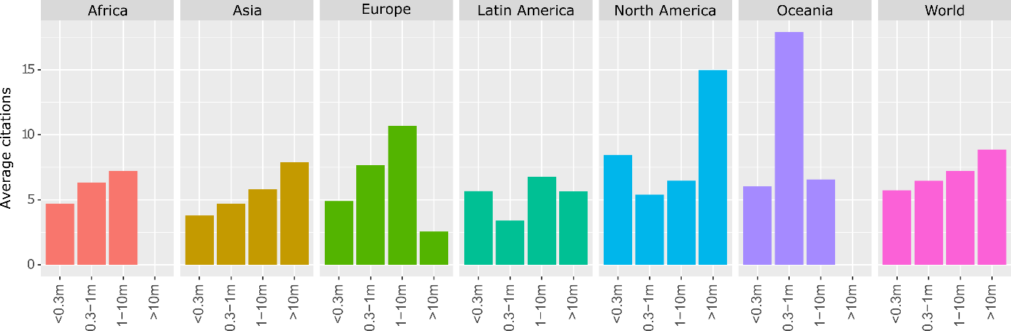

Figure 4: Average citations of urban case studies by region and city size

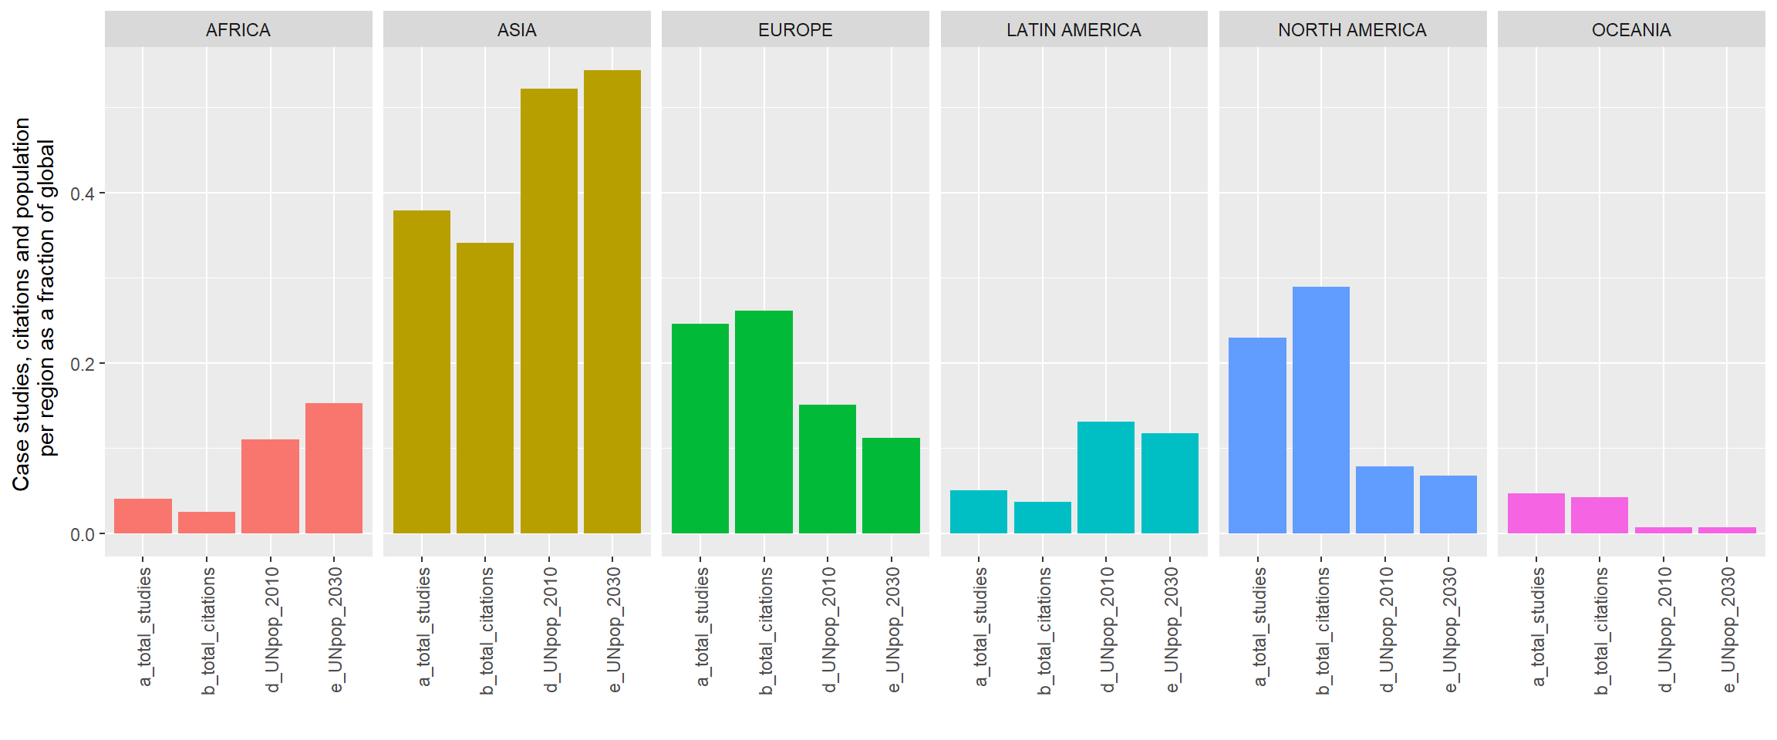

Fig 1: Regional biases in urban case study research and citations

|  |  |  |  |
| --- | --- | --- | --- |
| **ID** | **Topic Name** | **Stemmed Keywords** | **Marginal Topic Distribution** |
| 1 | Urban governance | citi; polici; govern; local; develop | 9.3 |
| 2 | Energy consumption | energi; consumpt; effici; sector; beij | 7.9 |
| 3 | Urban form | urban; area; land; ecolog; model | 7.2 |
| 4 | Solar PV | system; solar; power; electr; energi | 7.0 |
| 5 | CO2 emissions | carbon; emiss; industri; china; lowcarbon | 6.8 |
| 6 | Buildings | build; design; energi; perform; residenti | 6.8 |
| 7 | Climate adaptation | climat; chang; adapt; risk; govern | 6.5 |
| 8 | Air pollution | air; pollut; health; qualiti; concentr | 6.2 |
| 9 | Transportation | transport; travel; traffic; public; car | 5.7 |
| 10 | GHG emissions | ghg; emiss; greenhous; gas; reduct | 5.4 |
| 11 | Vehicles | vehicl; electr; fuel; drive; emiss | 4.8 |
| 12 | Households | household; incom; electr; survey; hous | 4.7 |
| 13 | Waste management | wast; landfil; solid; manag; msw | 4.6 |
| 14 | Water demand | water; suppli; manag; demand; treatment | 4.6 |
| 15 | Heat demand | heat; district; thermal; demand; network | 4.6 |
| 16 | Green roofs | roof; temperatur; cool; green; surfac | 4.5 |
| 17 | Urban ecology | tree; forest; plant; speci; sequestr | 3.4 |

Table 1: List of topics and their keywords

Table of comparative studies

Figure of regional comparisons